# Frontend Assignment

This assignment tries to replicate some of the common problems which one might face while creating web applications. Feel free to include general comments about your thought process and problems you face as you worked through this!

### Problem Statement

You need to create a common site layout

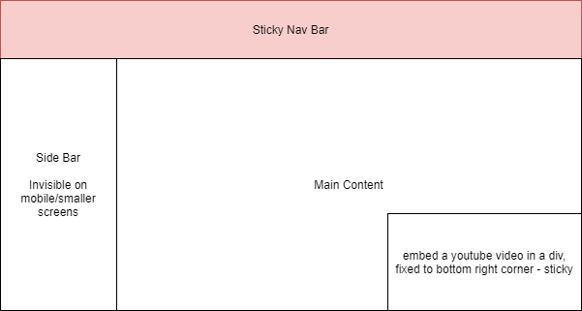

##### Task 1

The Navigation Bar should always stick to the top edge of the screen

The sidebar should only be visible on desktop/laptops.

A Youtube video should be embedded into the bottom right corner of the screen

##### IMG_257

##### Task 2

Explain how you would go about making the text more visible on the image, the image is dynamic and will change frequently, think of it as a banner atop websites

Implement the above wireframe, use a carousel for the image and text. (any library of your choice)

Implement dynamic text colors, (use any JS library of your choice) the text colors should change depending on the contents of the image